Sam Wood

29 September 2018

6: Python API Homework

1. Three observable trends based on the data:
   1. While statistically significant, there seems to be a large amount of variation in the relationship between max temperature and latitude (R sq = 55%), likely due to the varying elevations between cities.

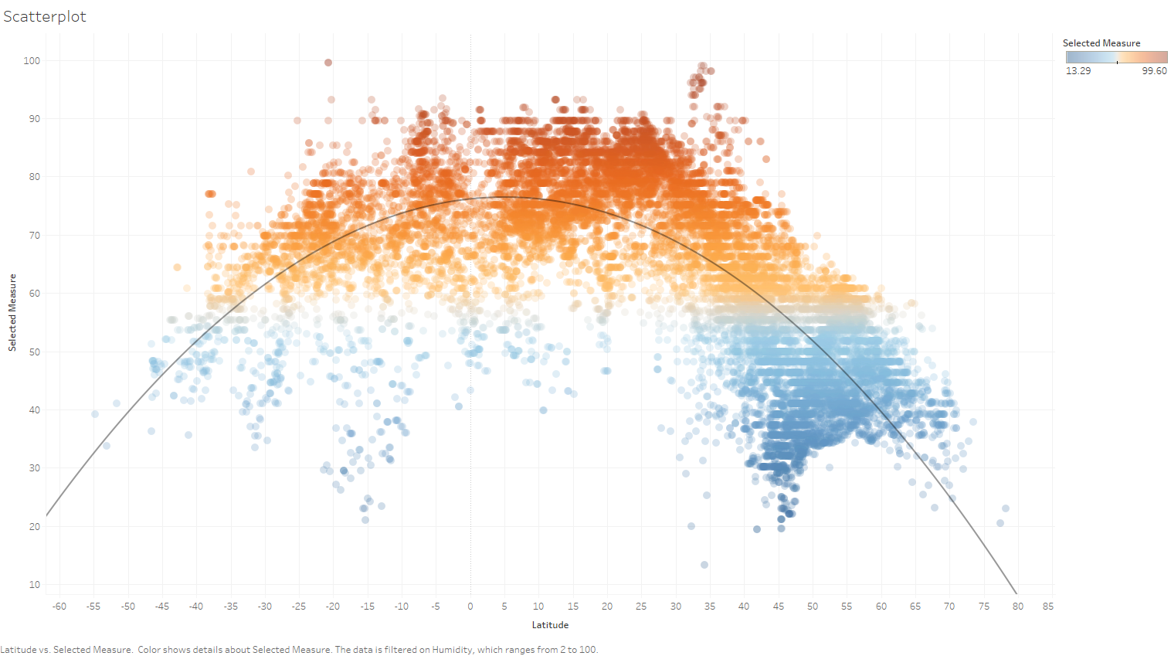

* 1. By incorporating elevation into the data set you can normalize the temperature using a rough estimate of 3.5 deg F decrease in temp for every 1000 ft increase in altitude. Plotting the adjusted temperature vs latitude yields a tighter correlation with R sq = 66.5%.

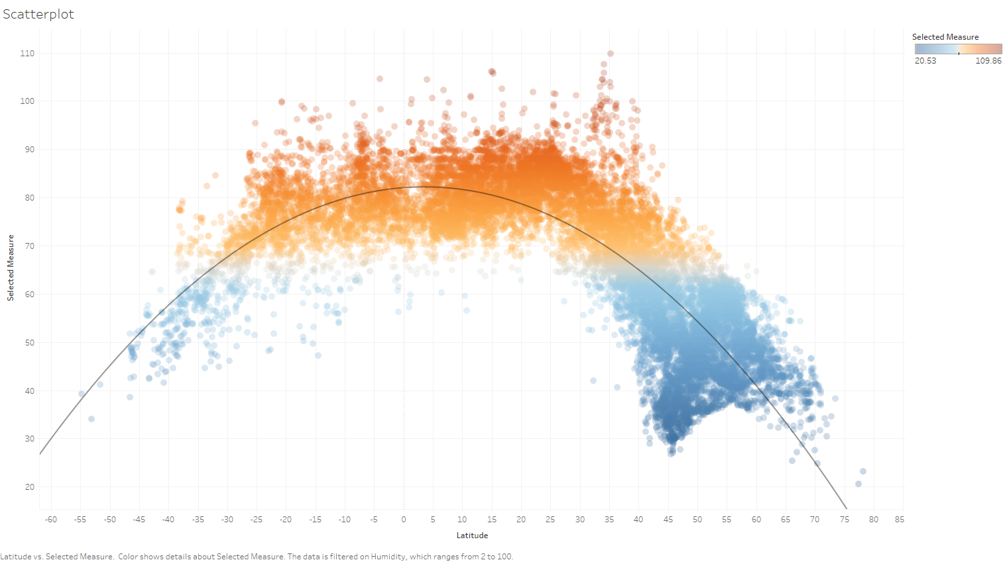

* 1. Humidity seems to have a bimodal distribution with “peaks” of low humidity around +40 and -25 latitude.

